* **[How to create a site with a template](https://sharepoint.rackspace.com/Learning/Articles/Pages/SharePoint-2013--how-to-create-a-site-with-a-template.aspx)**

If you have already watched [**SharePoint-2013: How to save your site as a template**](https://sharepoint.rackspace.com/Learning/Articles/Pages/SharePoint-2013--how-to-save-your-site-as-a-template.aspx) you're ready to create a new site from the saved template.  If you haven't watched it yet, check it out now! This tutorial will focus on creating a new subsite from a saved site template.

1. From your SharePoint site, on the Quick Launch, click **Site Contents**.

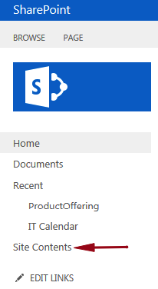

2. Scroll to the bottom under Subsites and click  **+ new subsite**.

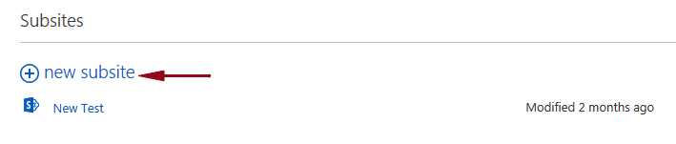

3. In the Title and Description section under Title: give it  a name, for this example I will it **New IT Subsite**.

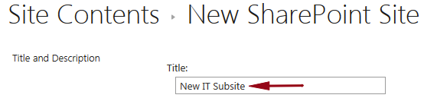

4. Under Description: type **This site was created using the IT Subsite Template**.

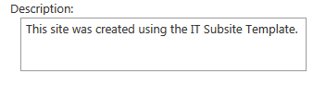

5. In the Web Site Address section under URL name: type **NewIT**.

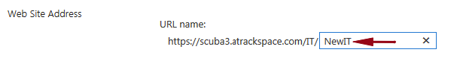

6. In the Template Section under Select a template: click **Custom**.

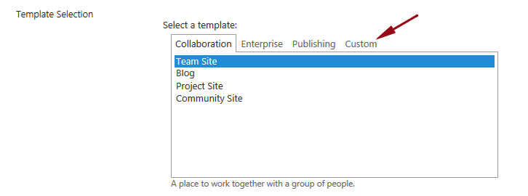

7. Click **IT Subsite**. (Which is the site template I created previously).

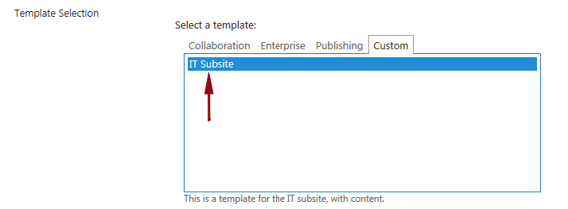

8. In the Navigation Inheritance section under Use the top link bar from the parent site click **Yes**.

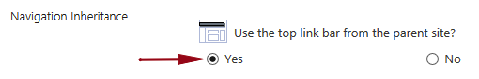

9. Click **Create**.

https://sharepoint.rackspace.com/Learning/Articles/PublishingImages/How%20to%20create%20a%20site%20with%20a%20template/createtemplate9.png

Looks good!

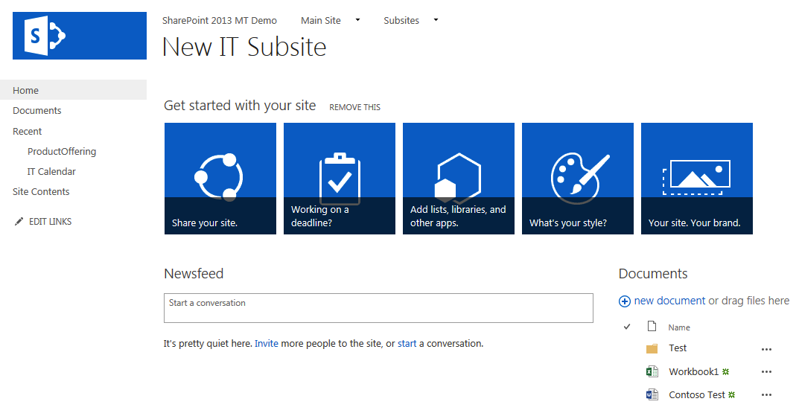

You will notice the saved site template I created in [**SharePoint 2013: How to save your site as a template**](https://sharepoint.rackspace.com/Learning/Articles/Pages/SharePoint-2013--how-to-save-your-site-as-a-template.aspx) has been applied to this site.